AFRINIC

🌐 What Is AFRINIC?
# Source: Chatgpt (GPT‑5 Mini) at [12/15/2025]
AFRINIC stands for African Network Information Centre. It is the Regional Internet Registry (RIR) responsible for managing:
- IP address allocations (IPv4 and IPv6)
- Autonomous System Numbers (ASNs)
…for organizations located in Africa and parts of the Indian Ocean region.

🧠 Simple Definition:
# Source: Chatgpt (GPT‑5 Mini) at [12/15/2025]
AFRINIC is the official organization that hands out IP addresses and AS numbers to ISPs, telecoms, and enterprises in Africa.

🌍 Region Covered by AFRINIC
# Source: Chatgpt (GPT‑5 Mini) at [12/15/2025]
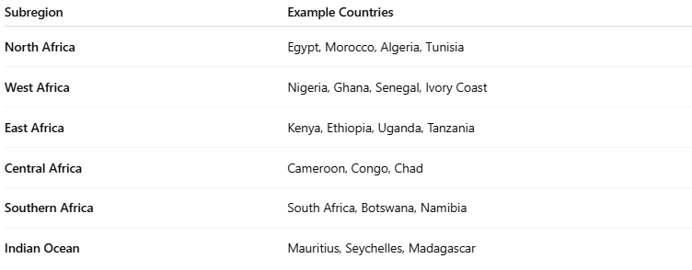

Subregion | Example Countries
North Africa | Egypt, Morocco, Algeria, Tunisia
West Africa | Nigeria, Ghana, Senegal, Ivory Coast
East Africa | Kenya, Ethiopia, Uganda, Tanzania
Central Africa | Cameroon, Congo, Chad
Southern Africa | South Africa, Botswana, Namibia
Indian Ocean | Mauritius, Seychelles, Madagascar

🔧 Core Responsibilities
# Source: Chatgpt (GPT‑5 Mini) at [12/15/2025]
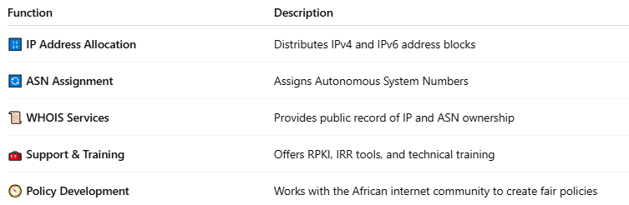

Function | Description
🔢 IP Address Allocation | Distributes IPv4 and IPv6 address blocks
🔄 ASN Assignment | Assigns Autonomous System Numbers
📜 WHOIS Services | Provides public record of IP and ASN ownership
🧰 Support & Training | Offers RPKI, IRR tools, and technical training
🧭 Policy Development | Works with the African internet community to create fair policies

🧾 WHOIS Example (from AFRINIC)
# Source: Chatgpt (GPT‑5 Mini) at [12/15/2025]
For IP block 196.201.0.0:
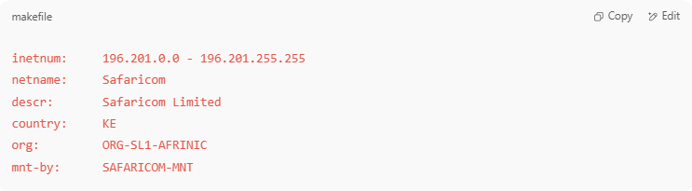
inetnum: 196.201.0.0 - 196.201.255.255
netname: Safaricom
descr: Safaricom Limited
country: KE
org: ORG-SL1-AFRINIC
mnt-by: SAFARICOM-MNT

📍 Headquarters & Website
# Source: Chatgpt (GPT‑5 Mini) at [12/15/2025]
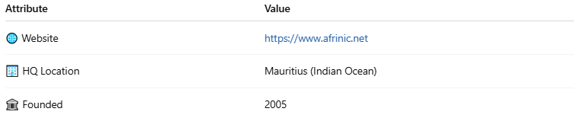

Attribute | Value
🌐 Website | https://www.afrinic.net
🏢 HQ Location | Mauritius (Indian Ocean)
🏛 Founded | 2005

🌐 AFRINIC vs Other RIRs
# Source: Chatgpt (GPT‑5 Mini) at [12/15/2025]
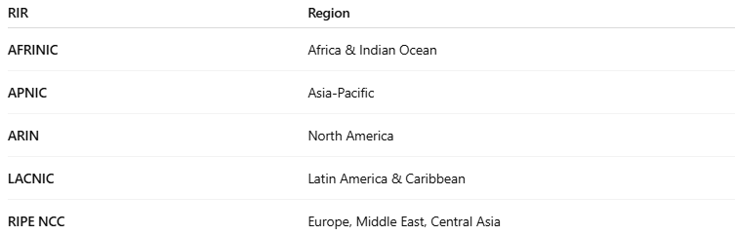

RIR | Region
AFRINIC | Africa & Indian Ocean
APNIC | Asia-Pacific
ARIN | North America
LACNIC | Latin America & Caribbean
RIPE NCC | Europe, Middle East, Central Asia

✅ Summary
# Source: Chatgpt (GPT‑5 Mini) at [12/15/2025]
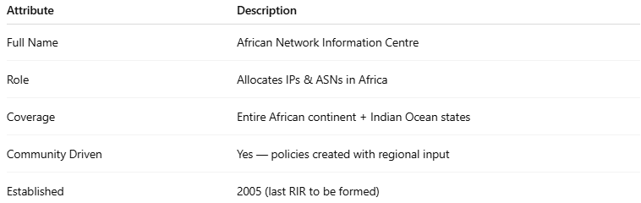

Attribute | Description
Full Name | African Network Information Centre
Role | Allocates IPs & ASNs in Africa
Coverage | Entire African continent + Indian Ocean states
Community Driven | Yes — policies created with regional input
Established | 2005 (last RIR to be formed)

